User Manual

Utilizing OSMnx to pull multiple image requests from Google Street View API

Our team used OSMnx to pull multiple images and metadata from Google Street View API. The script can pull four images from one location/node, North, South, East and West. Each user location will produce four different pictures. The user is able to request a location or define its parameters. The user can also set a defined radius in meters around a coordinate point. With these two requests from the user it will pull out all images and metadata within the location the user defines. The script can produce metadata of each location, which is free, before requesting images from Google Street View. Please be aware there are costs associated with requesting images through Google Street View API.

**Dependencies:**

* **Python 3.x**
* **Google Street View API key (You will need your own)**
* **JupyterLab**
* **MiniConda**
* **GitHub Repository**

**Instructions:**

**Step 1:**

Install Python 3.6 or newer from <https://www.python.org/downloads/>.

Install miniconda from <https://docs.conda.io/en/latest/miniconda.html>.

In the installer dialog, set the destination folder to C:\Anaconda (or the equivalent if you’re on a Mac, like ~/anaconda). Make sure both boxes are ticked to add Anaconda to the system path and to register Anaconda as the system default Python.

*Make sure you have the right miniconda version installed for your python version.

**Step 2:**

Install conda-forge to your channel. Open your command prompt (Windows) or terminal (Mac) and run the following commands:

**conda update -n base conda**

**conda config --prepend channels conda-forge**

Information on conda-forge can be found here <https://conda-forge.org/>.

**Step 3:**

Install the OSMnx package and jupyterlab by running the following commands:

**conda create -n ox --strict-channel-priority osmnx jupyterlab**

**conda activate ox**

**Step 4:**

To open jupyterlab run the following command:

**jupyter lab**

This will open your browser and direct you to JupyterLab. It should look like this:

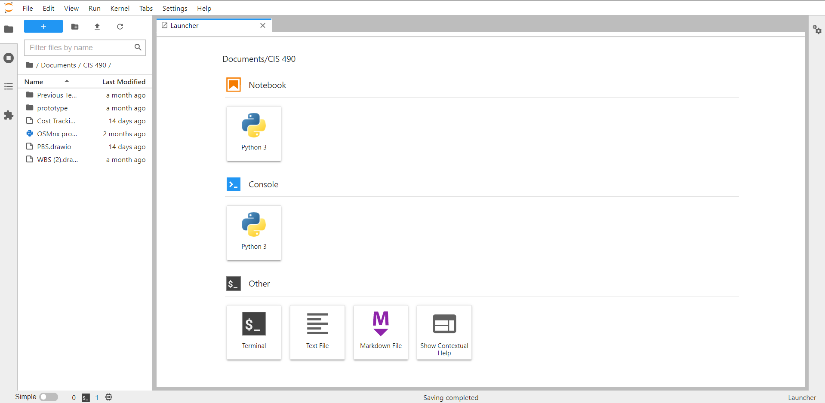

**Step 5:**

Clone the repository at <https://github.com/VinnyV97/Cougar-Student-Technologies>.

**Step 6:**

In order to run the script, use the directory on the left hand side to navigate to where you cloned the project.

Double click on **prototype_final.ipynb**. It should show you the script like this:

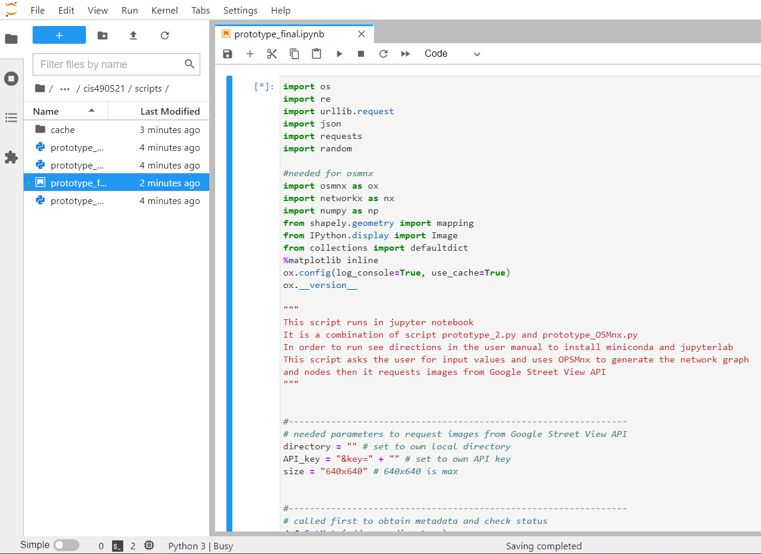

**Step 7:**

On line 30:  **directory = " " # set to own local directory** set the directory path to your own local directory.

On line 31: **API_key = "&key=" + " " # set to own API key** enter your own API key generated from your google account.

Access to the google cloud platform to generate an API key here <https://cloud.google.com/>.

**Step 8:**

Click on the play (red) button at the top left to run the script.

The user prompts will appear below the script as shown:

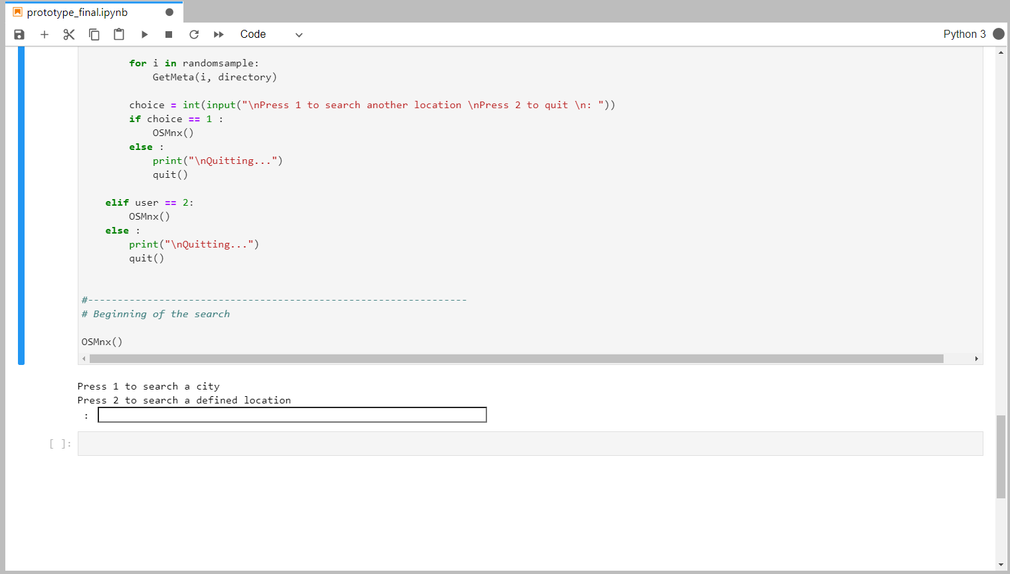

If the script freezes or an error occurs showing error messages, click on the replay (blue) button located near it to restart the kernel:

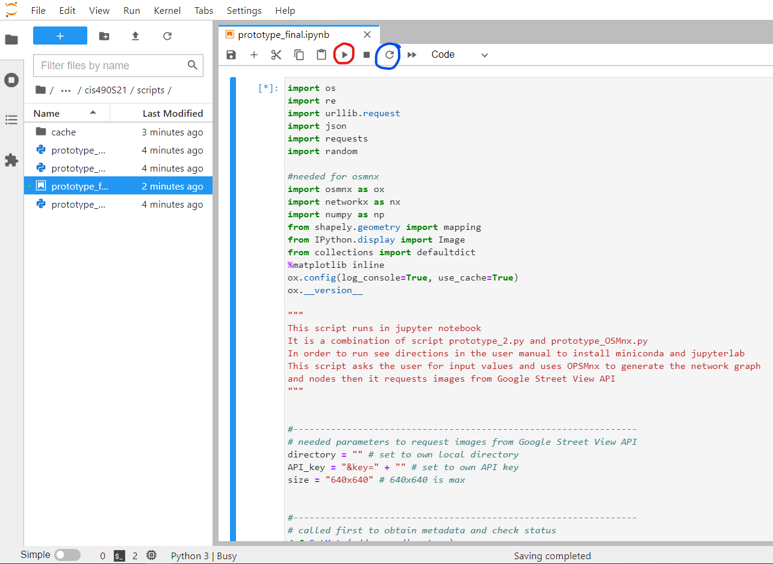

*if you are restarting the script, ensure the cell with the code is selected when you run it.

After the script runs check your directory path for the images and metadata

**Step 9:**

If you would like to reopen JupyterLab after closing your web browser and command prompt/terminal, simply run this command in your command prompt/terminal:

**activate ox**

Then run this command:

**jupyter lab**